Darkley Primary School Challenge
Hello boys and girls. I know you are all working hard on your home learning packs and on Mathletics and IXL. That is great. Keep it up but wait!!!!!!!!!!!!!!!!!!!
How about a different kind of challenge? How about a challenge that will test your creative senses, your practical, eco-friendly skills and give you all a break from Mathletics and IXL.

I challenge you all in………………………

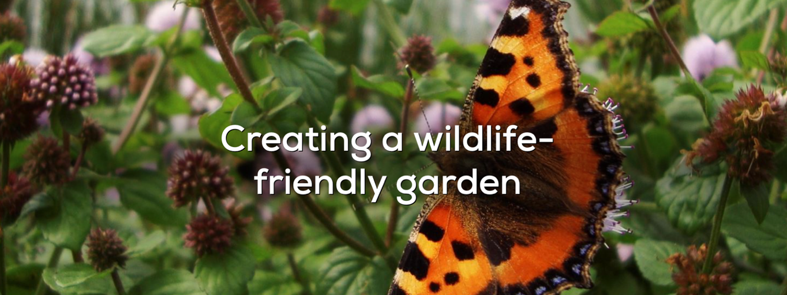

What I would love to see you have a go at is improve your garden space for wildlife. I love to garden boys and girls. It makes me feel very happy. I want you to send me some photos or short video clip of you completing your challenge. Maybe a written report, survey or a poem? Maybe a piece of artwork?

Your challenge could be to plant some flowers/seeds, create a bug hotel, wormery, a birdfeeder, hedgehog house, create a water station, build a birdhouse, record on a minibeast hunt, create your own compost café, animal shelter, identify/record birds in your garden……….. wherever your imagination takes you, so long as it improves wildlife.

To help you use this link below for ideas.

https://www.rspb.org.uk/birds-and-wildlife/advice/gardening-for-wildlife/creating-a-wildlife-friendly-garden/

You can send your photos or video clips via class dojo for Primary 1/2/3
P4-7 can send them to me at cmonaghan632@c2kni.net
Could you return them before Sunday 3rd May

Best of Luck, Mr Monaghan

